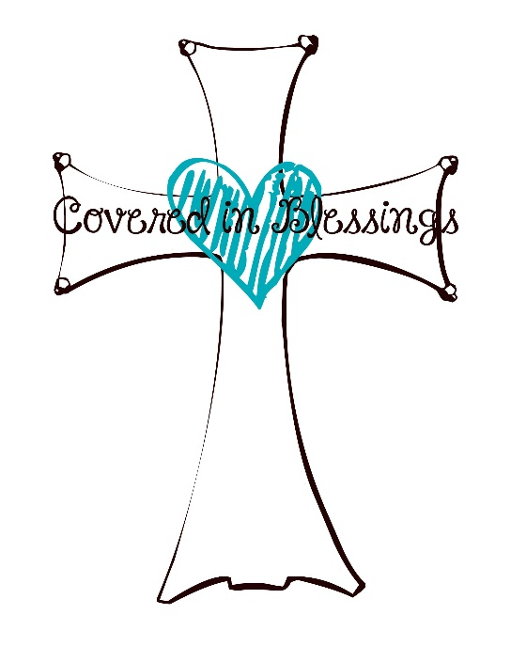
Candace Anness
972-333-5709
coveredinblessings@gmail.com
Embroidery of Hats/Visors
- $5.00/hat- For name only on side or back with Coaches Hats FREE.

*PLEASE RETURN THIS PAPER ALONG WITH YOUR MONEY & HATS. THANK YOU!
TEAM NAME_______________________ COACH’S NAME _____________________
CONTACT NUMBER__________________ FIRST GAME________________________
PRACTICE DATE, TIME & LOCATION________________________________________
PLEASE CIRCLE: SIDE OF CAP or BACK OF CAP
PLEASE CIRCLE: CASH, CHECK, PAYPAL OR VENMO TOTAL PAID_____
NAME AND/OR NUMBER TO BE MONOGRAMMED | NAME AND/OR NUMBER TO BE MONOGRAMMED

